

Foreign policy, international relations and security analysis

№01 15.01.2024-31.01.2024

Topics:

* Ukraine – European Union
* Foreign and Defense Policy of Ukraine
* The course of the Russian-Ukrainian war

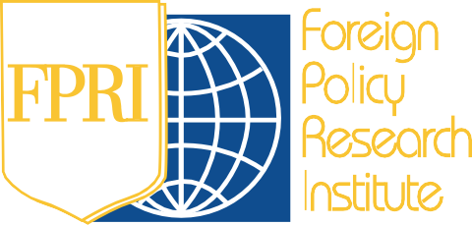

**CONTENT**

# UKRAINE - EUROPEAN UNION

*Theme Analysis:* The Ukrainian Peace Formula in Davos: Results and Prospects? *3*

# FOREIGN AND DEFENSE POLICY OF UKRAINE

*Theme Analysis:* Security Agreement between Ukraine and the UK: A NATO alternative or the foundation of a new security architecture in Europe? *6*

# THE COURSE OF THE RUSSIAN-UKRAINIAN WAR (01.10 – 15.10.2023)

Changes at the front *9* Military assistance *9* Russia: External and internal challenges *10*

**Ukraine – European Union**

*THEME ANALYSIS: The Ukrainian Peace Formula in Davos: Results and Prospects?*

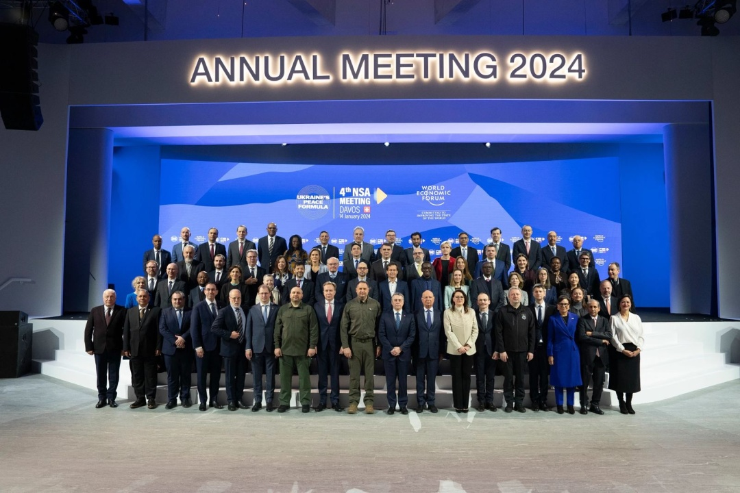

*Photo: Ukrinform*

On 14 January, the fourth meeting of national security advisers on the Ukrainian "Peace Formula" took place in Davos, Switzerland. The event was attended by 81 countries and international organizations, an increase compared to the previous meeting in Malta, where 66 countries were represented. According to Andriy Yermak, Head of the Office of the President of Ukraine, 39 European countries, 18 Asian countries, 12 African countries, 6 South American countries, 3 North American countries and 2 Oceania countries sent representatives to Davos.

According to him, this fourth meeting of the advisers in Davos is a logical continuation of the third meeting in Malta, where the first five points of Ukraine's "Formula for Peace" were considered, namely nuclear security, food and energy security, release of prisoners and deportees, including children, and restoration of Ukraine's territorial integrity and sovereignty.

Now, according to him, the next five points of the "formula" have been worked out in Davos. ***These include the withdrawal of Russian troops, restoration of justice, environmental safety, prevention of escalation and recurrence of the war, and confirmation of the end of the war*** Yermak stressed that, as in Malta, each of these points was presented by countries that are co-leaders of the relevant tracks of the "formula". He added that it is necessary to decide on further actions, in particular, to agree on the format of the Global Peace Summit. According to him, this will allow us to start developing detailed roadmaps for each of the points of the "formula", and the countries leading the relevant areas could hold thematic conferences to finalize the algorithms for their implementation.

Representatives of Lithuania and the Minister of Defence of Ukraine, Rustem Umerov, presented the results of the working group's progress on the aspect of *"Withdrawal of Russian troops and cessation of hostilities"*. It was noted that an international working group will be established to coordinate the withdrawal of Russian troops and occupation forces from the territory of Ukraine.

Representatives of the Netherlands, Prosecutor General Andriy Kostin and Deputy Minister of Justice of Ukraine Iryna Mudra, presented the progress of the working group dealing with the *"Restoration of Justice"* aspect. The working group is working on bringing to justice those responsible for the Russian aggression.

As for *Environmental Security*, Germany, Finland and Bulgaria continue to cooperate with Ukraine. The Minister of Ecology of Ukraine Ruslan Strilets noted that greenhouse gas emissions caused by the war in Ukraine exceed the total emissions in Austria.

The work on *"Preventing the escalation of the war and the recurrence of aggression"* was presented by the Head of the Office of the President of Ukraine Andriy Yermak and a representative of the United Kingdom. The basis for this matter is the Joint Declaration of Support for Ukraine, signed by the Group of Seven countries.

Deputy Head of the Presidential Office Andriy Sybiga and Minister of Justice Denys Malyuska presented the results of work on the topic of *"Confirmation of the end of the war"*. According to them, Ukraine has tried to conclude a relevant international agreement with Russia to formalize mutual relations and confirm the end of the war, but each time Russia has suspended or ignored its implementation.

During a press conference after the talks, the head of the President's Office, Andriy Yermak, said that Ukraine was interested in China's participation in the talks. Yermak expressed hope for a possible meeting with Chinese Premier Li Qiang at the Davos forum, which was to take place from 15 to 19 January. The head of the Presidential Administration also expressed hope that China would join the discussions on the "peace formula".[1] However, the Chinese side ignored the meeting. At the same time, Swiss Foreign Minister Ignazio Cassis added that China has significant influence, and it is important to find ways to cooperate with it on this issue.

The Swiss diplomat also made other statements regarding the Forum. Thus, he believes that the Ukrainian "Peace Formula" may be subject to certain modifications, as it is unlikely that one of the conflicting parties will accept proposals prepared by the other side: "We have to consider the form of such discussions, political and diplomatic efforts to find a way to open the door. After the first stage, we have a better vision of what is possible, what is impossible and what will be difficult to achieve. This had to be clarified before any further dialogue could take place," he proclaimed.[2]

Cassis suggests that the Ukrainian "Formula for Peace" is only one of the foundations for peace talks, serving as a starting point for further discussion. He points out that ***different countries have different positions on the events on the battlefield, and Ukraine's position does not coincide with Russia's.*** Cassis also emphasizes that developments on the battlefield will influence the negotiations. But it is also worth waiting for Russia's willingness to join and sit down at the negotiating table, which will also depend on these factors: "We have to be ready. And we should not wait for that moment to decide what to talk about. The military situation on the battlefield does or does not create the conditions to move forward. In the current situation, it is an illusion to imagine that Russia will accept our invitation. This is not the goal now, as we say. But we are preparing for the moment when Russia will be able to join and participate. This should be through the mediation of other countries to invite Russia on board. There is no alternative to this," he said.

This emphasis on the part of the Swiss representative caused some misunderstanding on the part of some media. However, it is important to understand what such platforms and initiatives are. **All of this is preparation for the establishment of a new world system**. **The Ukrainian-Russian war put an end to the world order that had prevailed before.** This is a conflict with global implications that will require the involvement of the entire world. Such platforms and agreements are the basis for further security processes that will involve most countries. **This is the formation of complexes of new regional systems and initiatives. That is why they are so important for Europe and the world, because they are a process of preparation.**

And as it has always been, a peace agreement is the end of any war. And it is concluded between two actors - the winner and the loser. Therefore, Russia is indispensable in signing a peace agreement. This is exactly what Cassis meant. **Yes, this will be preceded by a tough and uncompromising struggle, but then it will be time for diplomacy. And it will be diplomatic instruments such as the Formula for Peace platforms that will be the main driver of the new post-war world order.**

**Foreign and Defense Policy of Ukraine**

*THEME ANALYSIS: Security Agreement between Ukraine and the UK: A NATO alternative or the foundation of a new security architecture in Europe?*

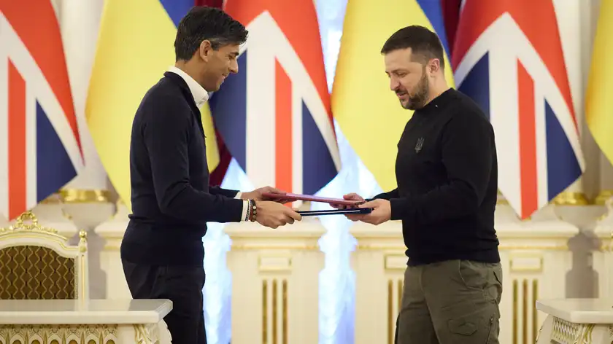

*Source: The Office of the President of Ukraine*

On 12 January 2024, during Rishi Sunak's visit to Kyiv, Ukraine and the United Kingdom signed a Security Cooperation Agreement. The agreement is a guarantee that Ukraine will not be left alone in confronting Russian aggression. This issue is especially relevant now, when many allies have begun to delay their assistance in the pre-election climate. The document secures further financial and military support for Kyiv.

**This is a great sign for Ukraine**, as after the G7 Declaration was published, there was a fear that these unspecified "guarantees" would become the only security assurance and a substitute for NATO membership. However, this agreement represents the realisation of the idea set out in the then G7 Joint Declaration at the NATO Summit in Vilnius in July 2023. At that time, due to the lack of countries that were willing to extend a full invitation to NATO, it was decided to develop multilateral or bilateral security agreements. **The UK played a key role in promoting this idea, and the agreement that was signed was the first of its kind.**

The UK has been proactive and decisive in Ukrainian matter from the start. Quite often, it has helped not only with material and military support, but also politically, persuading other states to take a more active stance towards Ukraine. In addition, this agreement is now important for London's political forces, including Rishi Sunakku, as a tool to improve their image.

The agreement is a major step forward for Ukraine in several ways. ***First and foremost, it serves as a means of assisting Ukraine in countering Russian aggression and guarantees continued support for the next 10 years.*** According to many forecasts, this is how long it will take for Kyiv to join NATO.

***Second, the agreement helps to consolidate the international coalition in support of Ukraine***, which was weakened in 2024 by the first serious difficulties with financial and military assistance, especially from the United States. It can serve as a rallying cry for other countries to act and get involved.

***Third, it clearly states support for Ukraine in restoring its internationally recognised borders as of 1991.*** This will complicate negotiations with advocates of peace deals with Russia at the cost of Ukrainian territory and is consistent with Ukraine's tough approach to such initiatives.

Returning to the invitation of other states. The best option would be to repeat this practice with the United States. This would give Ukraine a sense of confidence in continued security support in the event of a change of government. The negotiation process should have already begun, but the instability in Congress has slowed it down. However, there is hope that it will resume soon. This is confirmed by the statements of the US Ambassador to Ukraine, Bridget Brink,[3] who announced that she had held two rounds of talks with Kyiv on this very issue.

But other countries are also a possible option for further cooperation. For example, Japan has expressed a desire to hold similar talks, and other countries, particularly from Europe, may be interested in starting negotiations on possible agreements. This format provides Ukraine with a certain signal of support, even if the signatories are not directly involved in the conflict with Russia.

However, it is important to avoid exaggerated expectations when assessing this agreement. For example, it does not provide guarantees of joint collective defence. The United Kingdom notes that aggression against Ukraine violates the security of the United Kingdom, but **it does not provide for joint defence.**

Such an agreement could become an important tool for long-term cooperation, for example, in strengthening maritime security and helping to build up Ukraine's navy, which would eventually lead to the restoration of safe navigation in the Black Sea. In particular, it covers defence cooperation, including training of the Ukrainian military by British instructors. **But this agreement is not a direct alternative for NATO.**

A joint press conference between Volodymyr Zelenskyy and Rishi Sunak further confirmed this fact. When discussing the agreement, the Ukrainian president used the terms "**guarantees**" and "**security guarantees**", while the British prime minister used the phrase "**security assurances**", which reminds Ukrainians of the painful example of the Budapest Memorandum. In addition, the text published by the Office of the President of Ukraine mentions NATO several times. At the time, it was noted that London guaranteed support for Ukraine's accession to the Alliance.

***Despite the difficulties in obtaining an invitation to join NATO, the British are convinced that without membership in the Alliance, Ukraine will not have real guarantees of security and stability in the region.*** ***The agreement with the UK expresses the same idea.*** Among British experts, this formula is quite popular: although there is currently no political consensus in NATO on Ukraine's membership, the context may change, and Ukraine should be ready to respond quickly when favourable circumstances arise in the Alliance.

While the priority remains the movement towards NATO, the document clearly indicates support for Kyiv on this path, including relevant reforms in the armed forces and defence sector. This suggests that ***for the UK itself, the agreement serves as an interim step, supporting Ukraine in its defence until NATO membership becomes possible.***

It should also be remembered that there are still a number of obstacles on the path to NATO: Kyiv's lack of full control over Ukrainian territories, open hostilities, and obstacles from anti-Ukrainian countries such as Hungary and, more recently, Slovakia. This could delay Atlantic integration for years. But Ukraine doesn't have that much time to wait, so it needs some guarantees already. **Yes, the agreement with the UK cannot replace NATO's political influence and resources, but it is a good step to start building a security complex in Central and Eastern Europe as part of a new regional system of European security.**

To sum up, the agreement is a political framework and a green light for further agreements and practical steps. It is important to avoid euphoria and unrealistic expectations, as the real impact of the agreement will depend on the concrete actions taken by Ukraine, the UK and other states.

**The course of the Russian-Ukrainian war (01.10 – 15.10.2023)**

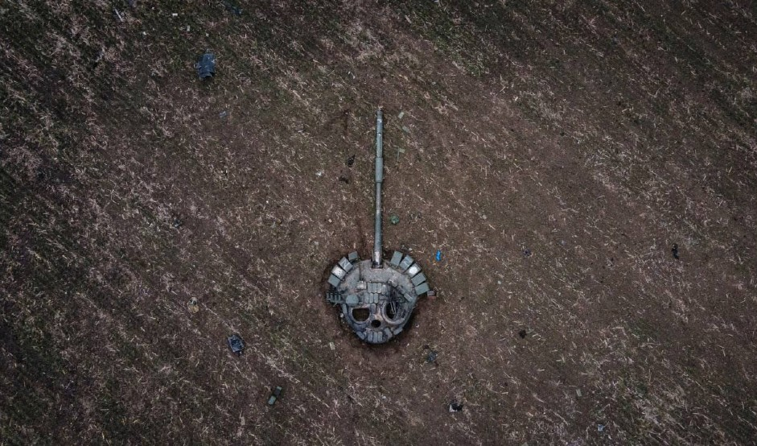

*Source: Army FM*

*Changes at the front*

**Trend:** ***Despite the critical shortage of ammunition and personnel in the units, the Ukrainian Defence Forces continue to hold back a large-scale offensive by Russian troops along the entire frontline***

**In the Volyn, Polissia, Siversky and Slobozhansky directions**, no signs of Russian offensive groups were detected.

**In the Kupyansk direction**, Russians fired at the settlements of Novomlynsk, Dvorichna, Zakhidne and Kindrashivka in the Kharkiv region.

**In the Liman direction**, Russians conducted unsuccessful offensive actions in the area north of Hryhorivka and near Spirne.

**In the Bakhmut direction**, Russians continues to conduct offensive actions. Fighting for the town of Bakhmut continues.

**In the Avdiivka direction**, Russians conducted offensive operations in the areas of Novokalynove, Severne, Vodiane, Pervomaiske and Nevelske, but were unsuccessful.

**In the Maryinka direction,** Ukrainian defenders repelled numerous enemy attacks near the town of Maryinka in the Donetsk region.

*Military assistance*

**The United States** confirmed the provision of long-range precision ground-launched bombs (GLSDBs) to Ukraine.

**France**: transferred two LRU multiple launch rocket systems.

**Germany**: On 26 January, the German Ministry of Defence announced the military aid that Ukraine will receive in 2024. In particular, it was about Gepard anti-aircraft systems, new IRIS-T air defence systems and more than 80 Leopard 1A5 tanks. In total, in 2024, the country plans to allocate more than €7 billion worth of aid to Ukraine.

* three WISENT 1 demining tanks;
* four Bandvagn 206 tracked all-terrain vehicles;
* missiles for IRIS-T SLS launchers;
* a Beaver bridge-building tank;
* 24 armoured personnel carriers;
* 14 mine trawls;
* four border protection vehicles;
* a marine demining system;
* Satcom surveillance system for satellite communications;
* 1040 155 calibre shells;
* 450 anti-slip chains.[4]

*Russia: External and internal challenges*

### Trend: Russia's military campaign plans for 2024

Almost two years have passed since Russia's full-scale invasion of Ukraine. The year of 2024 should be a new stage on the path to Ukraine's victory. But there will be plenty of threats and challenges. Moscow continues to do everything possible to achieve its ambitions.

Russia has no intention of ending the war it started. Vladimir Putin's teleconference on 14 December suggested that Russia will continue to fight until it achieves all its goals. While the dictator expectedly blamed Ukraine for his actions, in particular Kyiv's refusal to carry out "***denazification***".

But one thing is for sure, **the lack of an adequate assessment of its own actions and ambitions is what determines that Kremlin will go all the way.** In response to Putin's requests during an expanded meeting on 19 December, Russian Defence Minister Sergei Shoigu said that Russian troops would continue fighting in Ukraine and would carry out "all the tasks" set by their president.

However, they have already had to give up some ambitions. For example, it was planned that the Russian army would be able to capture Avdiivka before Putin's New Year's speech. However, they failed to do so. Right now, fierce fighting is still going on in the city, with the Russian side suffering heavy losses.

*"We are currently losing 200 to 600 soldiers a day near Avdiivka, and many of them are seriously wounded. Imagine if we intensify the assaults. In addition, the mobilised soldiers are now fighting worse,"* some Russian military officers described last year's Russian appetites in these words. [5]

**Such human losses are a big problem for Russia.** It is constantly trying to embellish the real situation. Thus, Putin continues to make statements that are far from reality. He said that the Russian armed forces are "improving their position" along the entire front line and added that the front line under Russian control is 2,000 kilometres. Meanwhile, the Russian Ministry of Defence said that it had fulfilled "all the goals set" for 2023.

Vladimir Putin also addressed the issue of personnel, saying that there are 617,000 Russian soldiers at the front in Ukraine. He noted that at the beginning of 2023, 486,000 people were "recruited" into the Russian army. Obviously, such a number does not allow Russia to achieve the objectives of the offensive, due to the huge losses incurred by Russian troops in its conduct. Therefore, it seems that Russia is trying to quickly fill its gaps in the high mortality rate of soldiers. For example, at the end of last year, **Sergei Shoigu announced his intention to increase the number of Russian military personnel to 1.5 million.** According to him, this decision was due to "growing external threats" to Russia, including Finland's accession to NATO and preparations for the approval of Sweden's future accession. Experts believe that this step may indicate the launch of a new wave of mobilisation in Russia, especially after the presidential election in 2024.

However, in an interview with RBC-Ukraine, Vadym Skibitskyi, head of the Defence Ministry's Main Intelligence Directorate, said that it is not necessary to expect a direct announcement of mobilisation. Rather, Russia will try to gradually recruit new soldiers every day*:" They have created all the conditions for mobilisation activities, including at the legislative level. There is a register of persons liable for military service. There are also plans to form and restore, for example, the Leningrad and Moscow military districts. And all this will affect the mobilisation needs of their armed forces... Every day, about 1,000-1,100 people join the ranks of the Russian armed forces. Let's put it this way: they are mobilising. It's just not as massive as it was in October-December 2022. "* [6]

He also said that in 2024, Russian troops plan to continue their attempts to reach the borders of Donetsk and Luhansk regions, a strategic objective set on 17 April 2022. An additional important goal for the invaders is to reach the Oskil River, eliminate the Robotynsky Ledge and the area where the Armed Forces operate within the left bank of the Kherson region.

However, some foreign publications predict Russia's appetites and goals are much greater. According to BILD, **Russia plans to seize large parts of Zaporizhzhia, Dnipro and Kharkiv regions, including the city of Kharkiv, in 2025-2026.** And the Institute for the Study of War (ISW) suggests that Russia is preparing false arguments to justify future aggression against NATO member states.[7]

Expert Colonel Serhiy Grabsky, a reserve colonel of the Armed Forces of Ukraine, is convinced that such plans exist, although they may be only interim options considered by the enemy. He notes that the implementation of such plans will require enormous efforts and resources, and doubts that Russia has sufficient capabilities to carry out such actions in the future. The expert emphasises that this could be aimed at unbalancing the coalition of states that support Ukraine.

Russia's unwillingness to expand the front line can also be seen in its enormous desire to restore and replenish military supplies, which are clearly lacking. Thus, in the summer of 2022, Moscow adopted laws and government decrees that effectively switched defence-industrial enterprises to wartime mode. The working week was extended, and some companies switched to three-month shifts. However, this does not guarantee that they will fully cope with the challenges of the defence industry.

The main focus is now on restoring equipment damaged on the battlefield and producing new weapons, including artillery systems, armoured vehicles and other military equipment. According to intelligence reports, the manufactured weapons are immediately sent to the frontline against Ukraine.

However, there are indications that **Russia may lack its own ammunition**, as evidenced by purchases from other countries, such as Iran and North Korea, and exports from warehouses in Belarus. It is also pointed out that production does not meet the needs of the Russian armed forces. For example, Russian enterprises produced only about 2 million 122-mm and 152-mm artillery rounds in 2023, which is not enough for the army's needs. Russia also wants to receive weapons from China or Central Asian countries.

As for the shelling of Ukraine and the threat from the sky, since the beginning of December, Russia has launched massive missile attacks on Ukraine, but its targets are not limited to energy facilities, as they were in previous periods. ***By circumventing sanctions and receiving support from third countries, Moscow is able to continue producing long-range missiles and increase production of attack drones such as the Shahid.***

To date, **the Russian Federation's main efforts have been focused on destroying Ukraine's infrastructure, including defence industry facilities, headquarters, command and control systems, and individual units located on the front line.**

As for the accuracy of the strikes, the Russian Federation uses various types of weapons, including Kinzhal hypersonic missiles. However, these strikes can be inaccurate, which is why they often result in civilian casualties.

The Russian Federation **has prioritised the destruction of air defence systems, aviation and defence industry facilities as a means of countering the build-up and strengthening of the Ukrainian Armed Forces.** All the necessary conditions for mobilisation measures have been created, including legislative grounds. There are plans to form and restore military districts, such as Leningrad and Moscow. The army is regularly replenished with new conscripts, about 1,000-1,100 people a day.

From this we can **conclude** that Russia is not slowing down its ambitions, but is furious at its inability to realise them quickly. That is why it will resort to radical actions and provocations. The year 2024 is indeed a turning point, when Russia has a chance to build up its power to satisfy its bloodthirsty appetites. Therefore, ***Ukraine should be prepared for a fierce defence, especially in the first half of the year. In addition, it should maintain a tough, uncompromising stance.*  Negotiations, despite their nature, provide Russia with an opportunity to restore its military capabilities, build up its forces and create strategic reserves to continue its aggression.**

It should also be remembered that Russia is looking for and successfully finding ways to circumvent sanctions and gain new allies. That is why ***Ukrainian partners should not delay too much in providing assistance,*** as they are still a potential target for Russia.

1. Працюємо над п'ятьма пунктами "формули миру": Єрмак про зустріч в Давосі. 14.01.2024. <https://suspilne.media/661280-pracuemo-nad-patma-punktami-formuli-miru-ermak-pro-zustric-v-davosi/?utm_source=copylink&utm_medium=ps>
2. У Давосі представник Швейцарії закликав «взяти Росію на борт» обговорень Формули миру. 14.01.2024 <https://www.ukrinform.ua/rubric-polytics/3813334-u-davosi-predstavnik-svejcarii-zaklikav-vzati-rosiu-na-bort-obgovoren-formuli-miru.html>
3. US has conducted two rounds of talks on security guarantees for Ukraine.12.01.2024. <https://www.pravda.com.ua/eng/news/2024/01/12/7437007/>
4. https://zaxid.net/news/
5. Наступ на фронті та цілі на 2024 рік: які заяви останнім часом лунають у Росії щодо війни в Україні. 20.12.2023 <https://tsn.ua/exclusive/plani-putina-na-2024-schodo-viyni-2475235.html>
6. Вадим Скібіцький: У росіян є мотивація воювати за гроші, щодня до армії йде близько 1000-1100 осіб. 15.01.2024. <https://gur.gov.ua/content/vadym-skibitskyi-u-rosiian-ie-motyvatsiia-voiuvaty-za-hroshi-shchodnia-do-armii-ide-blyzko-1000-1100-osib.html>
7. Росія готується до війни з НАТО: американські аналітики вказали на ознаки. 20.12.2023. https://tsn.ua/svit/rosiya-gotuyetsya-do-viyni-iz-nato-amerikanski-analitiki-vkazali-na-oznaki-2475571.html